Creador: David Rubio G.
Blog: https://soceame.wordpress.com/
GitHub: https://github.com/DRubioG
Fecha última modificación: 22/02/2025

Vivado tiene una biblioteca oculta que no enseña fácilmente pero existe. La biblioteca se llama «xpm»
Esta biblioteca contiene componentes que permiten hacer CDC(clock domain crossing), FIFOs síncronos y/o asíncronos, además de añadir memorias internas, etc.
Para acceder a estas librerías solo tienes que saber cómo se llama el componente. Los nombres están en la página web:
- Serie 7000: https://docs.amd.com/r/en-US/ug953-vivado-7series-libraries/Xilinx-Parameterized-Macros
- UltraScale: https://docs.amd.com/r/en-US/ug974-vivado-ultrascale-libraries/Design-Elements
Y con el componente solo hay que declararlo.
Ejemplo: imaginemos que necesito un FIFO asíncrono, pues solo necesito saber cuál es el nombre del componente que le da Vivado y declararlo.
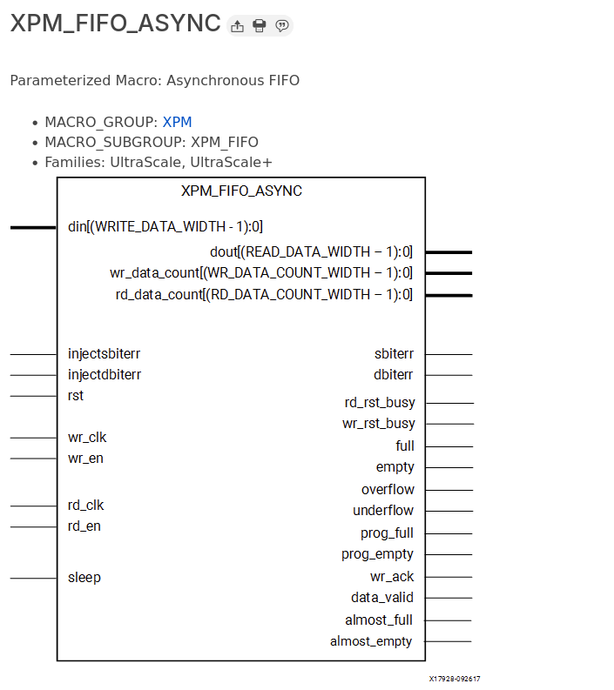
Para implementarlo solo se necesita declarar la librería
Library xpm;
use xpm.vcomponents.all;
Y después hacer la implementación, para la cuál en la página web describe cómo hacerlo.
-- xpm_fifo_async: Asynchronous FIFO
-- Xilinx Parameterized Macro, version 2023.2

xpm_fifo_async_inst : xpm_fifo_async
generic map (
CASCADE_HEIGHT => 0, -- DECIMAL
CDC_SYNC_STAGES => 2, -- DECIMAL
DOUT_RESET_VALUE => "0", -- String
ECC_MODE => "no_ecc", -- String
FIFO_MEMORY_TYPE => "auto", -- String
FIFO_READ_LATENCY => 1, -- DECIMAL
FIFO_WRITE_DEPTH => 2048, -- DECIMAL
FULL_RESET_VALUE => 0, -- DECIMAL
PROG_EMPTY_THRESH => 10, -- DECIMAL
PROG_FULL_THRESH => 10, -- DECIMAL
RD_DATA_COUNT_WIDTH => 1, -- DECIMAL
READ_DATA_WIDTH => 32, -- DECIMAL
READ_MODE => "std", -- String
RELATED_CLOCKS => 0, -- DECIMAL
SIM_ASSERT_CHK => 0, -- DECIMAL; 0=disable simulation messages, 1=enable simulation messages
USE_ADV_FEATURES => "0707", -- String
WAKEUP_TIME => 0, -- DECIMAL
WRITE_DATA_WIDTH => 32, -- DECIMAL
WR_DATA_COUNT_WIDTH => 1 -- DECIMAL
)
port map (
almost_empty => almost_empty, -- 1-bit output: Almost Empty : When asserted, this signal indicates that
-- only one more read can be performed before the FIFO goes to empty.

almost_full => almost_full, -- 1-bit output: Almost Full: When asserted, this signal indicates that
-- only one more write can be performed before the FIFO is full.

data_valid => data_valid, -- 1-bit output: Read Data Valid: When asserted, this signal indicates
-- that valid data is available on the output bus (dout).

dbiterr => dbiterr, -- 1-bit output: Double Bit Error: Indicates that the ECC decoder
-- detected a double-bit error and data in the FIFO core is corrupted.

dout => dout, -- READ_DATA_WIDTH-bit output: Read Data: The output data bus is driven
-- when reading the FIFO.

empty => empty, -- 1-bit output: Empty Flag: When asserted, this signal indicates that
-- the FIFO is empty. Read requests are ignored when the FIFO is empty,
-- initiating a read while empty is not destructive to the FIFO.

full => full, -- 1-bit output: Full Flag: When asserted, this signal indicates that the
-- FIFO is full. Write requests are ignored when the FIFO is full,
-- initiating a write when the FIFO is full is not destructive to the
-- contents of the FIFO.

overflow => overflow, -- 1-bit output: Overflow: This signal indicates that a write request
-- (wren) during the prior clock cycle was rejected, because the FIFO is
-- full. Overflowing the FIFO is not destructive to the contents of the
-- FIFO.

prog_empty => prog_empty, -- 1-bit output: Programmable Empty: This signal is asserted when the
-- number of words in the FIFO is less than or equal to the programmable
-- empty threshold value. It is de-asserted when the number of words in
-- the FIFO exceeds the programmable empty threshold value.

prog_full => prog_full, -- 1-bit output: Programmable Full: This signal is asserted when the
-- number of words in the FIFO is greater than or equal to the
-- programmable full threshold value. It is de-asserted when the number
-- of words in the FIFO is less than the programmable full threshold
-- value.

rd_data_count => rd_data_count, -- RD_DATA_COUNT_WIDTH-bit output: Read Data Count: This bus indicates
-- the number of words read from the FIFO.

rd_rst_busy => rd_rst_busy, -- 1-bit output: Read Reset Busy: Active-High indicator that the FIFO
-- read domain is currently in a reset state.

sbiterr => sbiterr, -- 1-bit output: Single Bit Error: Indicates that the ECC decoder
-- detected and fixed a single-bit error.

underflow => underflow, -- 1-bit output: Underflow: Indicates that the read request (rd_en)
-- during the previous clock cycle was rejected because the FIFO is
-- empty. Under flowing the FIFO is not destructive to the FIFO.

wr_ack => wr_ack, -- 1-bit output: Write Acknowledge: This signal indicates that a write
-- request (wr_en) during the prior clock cycle is succeeded.

wr_data_count => wr_data_count, -- WR_DATA_COUNT_WIDTH-bit output: Write Data Count: This bus indicates
-- the number of words written into the FIFO.

wr_rst_busy => wr_rst_busy, -- 1-bit output: Write Reset Busy: Active-High indicator that the FIFO
-- write domain is currently in a reset state.

din => din, -- WRITE_DATA_WIDTH-bit input: Write Data: The input data bus used when
-- writing the FIFO.

injectdbiterr => injectdbiterr, -- 1-bit input: Double Bit Error Injection: Injects a double bit error if
-- the ECC feature is used on block RAMs or UltraRAM macros.

injectsbiterr => injectsbiterr, -- 1-bit input: Single Bit Error Injection: Injects a single bit error if
-- the ECC feature is used on block RAMs or UltraRAM macros.

rd_clk => rd_clk, -- 1-bit input: Read clock: Used for read operation. rd_clk must be a
-- free running clock.

rd_en => rd_en, -- 1-bit input: Read Enable: If the FIFO is not empty, asserting this
-- signal causes data (on dout) to be read from the FIFO. Must be held
-- active-low when rd_rst_busy is active high.

rst => rst, -- 1-bit input: Reset: Must be synchronous to wr_clk. The clock(s) can be
-- unstable at the time of applying reset, but reset must be released
-- only after the clock(s) is/are stable.

sleep => sleep, -- 1-bit input: Dynamic power saving: If sleep is High, the memory/fifo
-- block is in power saving mode.

wr_clk => wr_clk, -- 1-bit input: Write clock: Used for write operation. wr_clk must be a
-- free running clock.

wr_en => wr_en -- 1-bit input: Write Enable: If the FIFO is not full, asserting this
-- signal causes data (on din) to be written to the FIFO. Must be held
-- active-low when rst or wr_rst_busy is active high.

);

-- End of xpm_fifo_async_inst instantiation

Nota final
En esta misma página también viene descrito como utilizar la librería UNISIM, que permite utilizar lógica de la FPGA de forma directa (LUTs, BUFG, DSP48E2, RAM, etc). Como por ejemplo como meter un buffer para reloj en una FPGA.
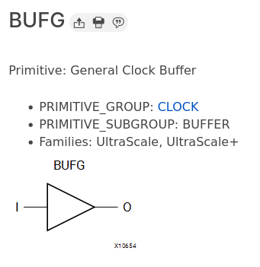
Con un ejemplo de instanciación
